**ASSIGNMENT #1**

1. Create a database consisting of the tables in Figure 1. You can import the tblCustomer.csv, tblMortgage.csv, and tblPropertyOwner.csv files available on LEARN. Add the entries in Figure 2 to the Customer table **BEFORE** you set the foreign key relationships. Back up the database and upload the .bak file to the LEARN Dropbox along with this completed Worksheet. **(5 MARKS)**

**Figure 1**

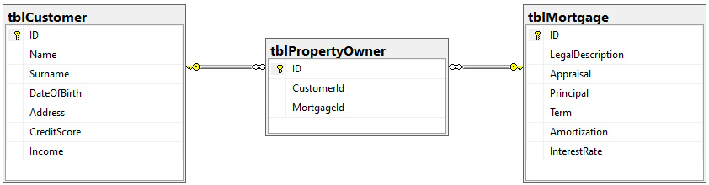

**Figure 2**

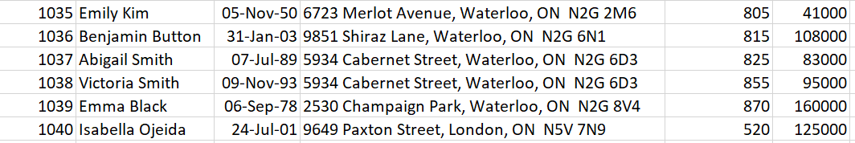

1. Calculate the CMHC Mortgage Insurance for all *applicable* mortgages. **(3 MARKS)**

To calculate the CMHC Mortgage Insurance for all applicable mortgages, the first step I took was to create a new table containing the property owners; first and last name, credit score, income, property appraisal, down payment, amortization period and interest rate. I did this using SQL through the query provided in Figure 3.

**Figure 3**

Then with this information nicely formatted in a table, I was able to use the CMHC mortgage calculator at the link: <https://www.cmhc-schl.gc.ca/consumers/home-buying/calculators/mortgage-calculator> to calculate the property owners mortgage for all applicable mortgages. Figure 4 provides the results in the column named mortgageInsurance, note that I made the assumption that the mortgage will be paid monthly.

**Figure 4**

While conducting the calculations I noticed there were some properties that could not be entered into the calculator (shown in Figure 4 with the highlighted NULL value). I referred to the general requirements to qualify for homeowner mortgage loan insurance to understand why the property mortgages wouldn’t be calculated. The general requirements to qualify for homeowner mortgage loan insurance through the link: <https://www.cmhc-schl.gc.ca/consumers/home-buying/mortgage-loan-insurance-for-consumers/what-are-the-general-requirements-to-qualify-for-homeowner-mortgage-loan-insurance>.

Here I will explain the NULL values shown in Figure 4.

Line 2: Amortization period is greater than 25 years.

Line 3: Amortization period is greater than 25 years.

Line 6: Appraisal (Property value) is greater than $1,000,000.

Line 14: Appraisal (Property value) is greater than $1,000,000.

Line 15: Appraisal (Property value) is greater than $1,000,000.

Line 21: Amortization period is greater than 25 years.

Line 22: Amortization period is greater than 25 years.

Line 23: Amortization period is greater than 25 years.

1. Which Mortgages are most likely to default and why? **(2 MARKS)**

<https://www.cmhc-schl.gc.ca/consumers/home-buying/calculators/mortgage-calculator>

<https://www.cmhc-schl.gc.ca/consumers/home-buying/mortgage-loan-insurance-for-consumers/what-are-the-general-requirements-to-qualify-for-homeowner-mortgage-loan-insurance>

<https://www.investopedia.com/terms/g/grossdebtserviceratio.asp#:~:text=The%20gross%20debt%20service%20(GDS,in%20comparison%20to%20their%20income>.

<https://www.ratehub.ca/blog/new-cmhc-rules-covid-19/>

<https://www.ratehub.ca/cmhc-mortgage-insurance>

<https://www.nesto.ca/calculators/cmhc-insurance/>